Nepal College of Information Technology
Balkumari Lalitpur
Unit Test Spring Semester 2008

Filter Design
Year: 2008 FM: 70
Sem: VI PM: 35
Program ELX Time: 2hrs
Attempt all the questions:

1. a) What are the steps involved in filter design technologies? (5)
b) Following circuit is a low pass filter designed at normalized frequency of w=1rad/sec. (10)
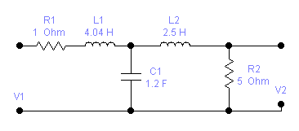
Apply frequency scaling so that the normalizing frequency is 10^4rad/sec and magnitude scaling to get realizable elements.

2. a) For the following specification of a LPF, calculate the order of Chebyshev filter.
α_{max=} 0.5dB, α_{min=} 22dB, w_{p}=1, w_{s}=2.33 (5)

b) Derive expression to find the order of Butterworth filter. (10)

OR
Derive expression to find the order of Chebyshev filter.

3. a) Compare Butterworth and Chebyshev responses. (5)
b) Find the Butterworth transfer function to meet the order n=4. Also find the half power frequency and the location of poles and zeros. (10)

4. a) Considering the delay response, which filter would you select among Butterworth, Bessel Thomson and Chebyshev and why? (5)
b) It is required to design a band stop filter with rejection band that extends from w=10⁵rad/s to w=4x10⁵rad/s. 10

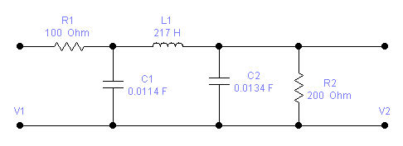

5. Write short notes on (any two) (5x2=10)
i) Group delay and phase delay
ii) Importance of scaling
iii) Delay equalization

